CE213 Class Problem Sheet 4 (Week 5)

A short Q&A session for any questions about assignment, progress test, and lectures: …
MCQ used in polls in lectures:
3-11-2020
Which of the following statements is true?
[A] Minimax search does not use heuristics to evaluate non-leaf nodes in the game tree.
[B] Alpha-beta pruning can speed up minimax search but will not influence the value returned to the root node by minimax search.
[C] In minimax search no criteria for node selection are required for node expansion in the process of game tree construction, whilst Monte-Carlo tree search does node selection for node expansion in the process of game tree construction.
[D] All of the above
(Answer: D)

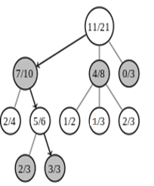
(Q1) The diagram below shows a game tree, with the number within each node representing the ratio of number of wins to number of visits. Justify that the node with the win ratio of 3/3 should be selected for expansion next using the following upper confidence bound as exploration-exploitation trade-off:
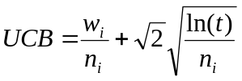
w_{i} : no. of wins after visiting node i
n_{i} : no. of times node i has been visited.
t : no. of times the parent of node i has been visited.

[The result has been presented in the lecture.
This exercise is to ensure you know how to
calculate UCB and how to use UCB values to
select a node for expansion.]

(Q2) The following set of rules forms a simple production system:
Rule 1: IF waffleshaft is grimped
THEN CONCLUDE grudline is thwarted
Rule 2: IF ascerbic index exceeds 10
THEN CONCLUDE remedy is hyposubduction
Rule 3: IF ascerbic index exceeds 5
THEN CONCLUDE spriggot is frenetic
Rule 4: IF grudline is thwarted
AND detractor is active
THEN CONCLUDE remedy is dephlogistination
Rule 5: IF quadrenometer indicates surfeit
THEN CONCLUDE detractor is active
Rule 6: IF euphoria is falling
THEN CONCLUDE detractor is active
Initially, the following four facts are loaded into working memory:
The waffleshaft is grimped
The ascerbic index is 7
The quadrenometer indicates no surfeit
Euphoria is falling
- A forward chaining interpreter uses recency as its main conflict resolution strategy and any remaining conflicts are resolved by choosing the first matched rule in the list. Trivial loops are prevented by refractoriness. Assume the above four facts have the same recency. Describe the sequence of operations (rule firing) that will take place in order to find a remedy. List all the facts that will be in working memory when execution stops.
- Describe the sequence of operations (rule firing) that will take place if the set of rules is interpreted by an exhaustive backward chaining interpreter given the goal of finding a remedy. List all the facts that will be in working memory when execution stops.

[N.B. This production system may be meaningless, but it is good for practicing production rule interpretation and for demonstrating the effect of conflict resolution.]
More questions (could be for homework):

1. How are game positions evaluated in minimax search and Monte-Carlo tree search respectively?

2. What problems are more suitable to be solved by expert systems rather than state space search?

3. What are the main differences between forward chaining and backward chaining?

4. What problems/tasks are more suitable to be solved by forward chaining interpreters?
5. What problems/tasks are more suitable to be solved by backward chaining interpreters?
Topics: game playing (MCTS), forward chaining, backward chaining
Answers:
Q1: The UCB values of the nodes are calculated and indicated in the figure below. It can be seen that the node with the win ratio of 3/3 has the highest UCB value and its parent node and parent’s parent node also have larger UCB values. Therefore, it should be selected for expansion next [There are two ways to select: 1. Select the child node of the root node, which has the largest UCB value, then select the child node of the previously selected node, which has the largest UCB value, and repeat this until a leaf node is selected. 2. Select the node that has the largest UCB value among the unexpanded nodes. The second way is simpler, but may not work well for some game trees.]

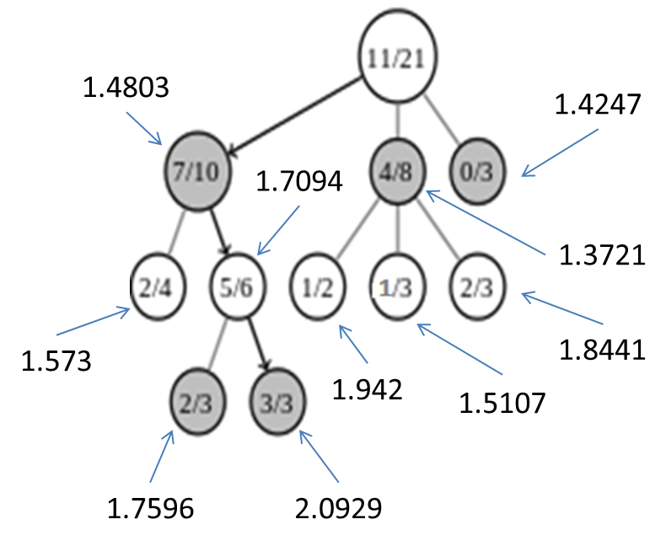
e.g., for node with win ratio 7/10: UCB=7/10+sqr(2)*sqr[ln(21)/10]=1.4803…
Q2:
(i)
- Assuming the initial four facts have the same recency:
sequence of operations:
1st match-execute cycle: Rule 1 fires, adding grudline is thwarted to working memory
2nd match-execute cycle: Rule 3 fires, adding spriggot is frenetic to working memory
3rd match-execute cycle: Rule 6 fires, adding detractor is active to working memory
4th match-execute cycle: Rule 4 fires, adding remedy is dephlogistination to working memory
All the facts in working memory when execution stops:
The waffleshaft is grimped
The ascerbic index is 7
The quadrenometer indicates no surfeit
Euphoria is falling
Grudline is thwarted
Spriggot is frenetic
Detractor is active
Remedy is dephlogistination

- Assuming ‘Euphoria is falling’ is the most recent fact and ‘waffleshaft is grimped’ the least recent fact among the four initial facts:
sequence of operations:
1st match-execute cycle: Rule 6 fires, adding detractor is active to working memory
2nd match-execute cycle: Rule 3 fires, adding spriggot is frenetic to working memory
3rd match-execute cycle: Rule 1 fires, adding grudline is thwarted to working memory
4th match-execute cycle: Rule 4 fires, adding remedy is dephlogistination to working memory
All the facts in working memory when execution stops:
The waffleshaft is grimped
The ascerbic index is 7
The quadrenometer indicates no surfeit
Euphoria is falling
Detractor is active
Spriggot is frenetic
Grudline is thwarted
Remedy is dephlogistination
(ii)
Sequence of hypothesis testing:

Initial hypothesis: remedy is X
Rule 2: LHS fails
Rule 4: LHS not sure
Subsidiary hypothesis: grudline is thwarted
Rule 1: LHS satisfied. Add grudline is thwarted to working memory.
Subsidiary hypothesis: detractor is active
Rule 5: LHS fails
Rule 6: LHS satisfied. Add detractor is active to working memory.
Rule 4: LHS satisfied. Add remedy is dephlogistination to working memory.

Sequence of operations:
Rule 1, Rule 6, and Rule 4 will fire in turn.

All the facts that will be in working memory when execution stops:
The waffleshaft is grimped
The ascerbic index is 7
The quadrenometer indicates no surfeit
Euphoria is falling
Grudline is thwarted
Detractor is active
Remedy is dephlogistination
[In comparison with forward chaining, backward chaining doesn’t need conflict resolution and usually uses less working memory (e.g., rule 3 has not fired).]

More questions (could be for homework):
1. Minimax search: Evaluate endgame positions first if possible and then backtrack their values to the current game position by alternative minimising and maximising steps. If endgame positions are too deep to be backtracked within reasonable time, evaluate game positions at certain depth using some heuristics and then backtrack their values to the current game position by alternative minimising and maximising steps.
MCTS: A large number of iterations of ‘(node) selection, (node) expansion, simulation, and backpropagation’ are executed. In each iteration, a simulated game is played with random moves from the selected leaf node to endgame, and based on the outcome of the simulated game (win, loss, or draw) the win ratios (values) of the game positions corresponding to the nodes on the path of backtracking from the selected leaf node to the root node are updated.

2. Problems whose solutions cannot be represented as a sequence of state transitions, or in which state transitions are difficult to define and states are difficult to evaluate. Examples include medical diagnosis and financial market prediction.

3.
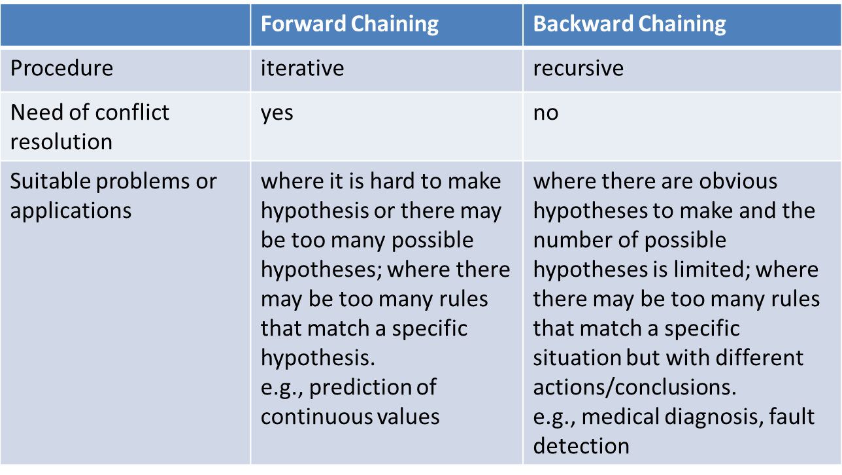

4. Problems in which it is difficult to form a hypothesis, such as prediction of the value of a continuous variable.

5. Problems with a small number of clear possible hypotheses that could be created and whose facts may match a large number of rules, such as medical diagnosis.

